

project report

Development of a Multi-Source Deep Learning Model for Stock Market Prediction on JCI

JORDAN THEOVANDY

23.K1.0018

Faculty of Computer Science

Soegijapranata Catholic University

2026

DECLARATION OF AUTHORSHIP

I, the undersigned:
Name : Jordan Theovandy
ID : 23.K1.0018

Titled “Development of a Multi-Source Deep Learning Model for Stock Market Prediction on JCI”, and the work presented in it is my own. I confirm that:
- This work was done wholly or mainly while in candidature for a research degree at Soegijapranata Catholic University
- Where any part of this thesis has previously been submitted for a degree or any other qualification at this University or any other institution, this has been clearly stated.
- Where I have consulted the published work of others, this is always clearly attributed.
- Where I have quoted from the work of others, the source is always given.
- Except for such quotations, this work is entirely my own work.
- I have acknowledged all main sources of help.
- Where the work is based on work done by myself jointly with others, I have made clear exactly what was done by others and what I have contributed myself.
Semarang, June, 05, 2026

JORDAN THEOVANDY
23.K1.0018
Table of Contents
Chapter 1. Introduction 2
Chapter 2. Research Method 8
2.1 Data Collection 8
2.2 Data Preprocessing 11
2.2 Proposed Model 14
2.3 Experimental Setup 16
2.4 Experimental Scenario 17
2.5 Performance Evaluation 18
Chapter 3. Result and Discussion 20
3.1. Results 20
3.1.1. Predictive Performance Evaluation (Classification Metrics) 20
3.2.1. Relationship to the Efficient Market Hypothesis 23
Chapter 4. Conclusion 26
REFERENCES 29

List of Figures
Figure 1. Big Picture Architecture 5

List of Tables
Table 1. Sample Table of JCI Price Data 2018-2025 6
Table 2. Sample Table of USD/IDR Exchange Rates for 2025 6
Table 3. Sample Table of BI-Rate Data for 2025 6
Table 4. Sample Table of Inflation Data for 2025 7
Table 5. Architecture Specifications of the Proposed Hybrid Model 10

ACKNOWLEDGMENT

First and foremost, I would like to express my deepest gratitude to God, Jesus Christ, for His abundant grace, blessings, guidance, and strength throughout my academic journey. Without His faithfulness and provision, the completion of this thesis would not have been possible.

I would like to extend my sincere appreciation to my supervisor, Mrs. Shinta Estri Wahyuningrum, for her continuous guidance, constructive feedback, patience, and invaluable support throughout the entire research process. Her expertise and direction have been instrumental in shaping this study and encouraging me to achieve my best.

I would also like to express my gratitude to the Computer Science Program at Soegijapranata Catholic University for providing the academic environment, facilities, and resources necessary for the completion of this research.

My heartfelt thanks go to my beloved parents, especially my mother and father, for their unconditional love, endless prayers, unwavering encouragement, and countless sacrifices. Their emotional and moral support has been my greatest source of strength and motivation. I am also deeply grateful to my entire family for always believing in me and standing by my side throughout my academic journey.

I would also like to extend my heartfelt appreciation to my close friends from the Computer Science Program Darren, Johan, Cristian, Chandra, and Roger. Thank you for your friendship, support, and the countless moments we shared from the very beginning of our academic journey. Your encouragement, collaboration, and companionship through both challenges and successes have made my university experience truly memorable and have played a significant role in helping me persevere until the completion of this thesis.

Finally, I would like to express my appreciation to all friends and colleagues who have directly or indirectly contributed to this research. Your support, collaboration, and companionship have made this journey both meaningful and memorable.

I acknowledge that this thesis is not without limitations. Therefore, I sincerely welcome constructive criticism and suggestions for future improvement. I hope that this work will provide meaningful value and contribute to the advancement of knowledge and future research in this field.

ABSTRACT
This study evaluates whether adaptive multi-source fusion improves weekly Jakarta Composite Index direction prediction. We combine an LSTM over technical indicators $(28-day lookback)$, an MLP encoder over macroeconomic variables (BI Rate, inflation, USD/IDR), and frozen IndoBERT embeddings of Indonesian financial news $(20,784 articles, 2018-2025)$ through a soft-gating network that learns per-modality weights, forecasting $t+5$ direction under purged expanding-window walk-forward validation $(5 folds, gap=33)$. The full model attains pooled $AUC 0.4913$ — indistinguishable from chance — with every paired $ΔAUC 95\%$ confidence interval across six variants covering zero. The macro encoder adds only $+0.003 AUC$over the technical-only LSTM (paired $ΔAUC +0.003 [-0.100, +0.106]$); the news gate converges to $γ ≈ 0.09$, a learned suppression of noise rather than optimization failure, confirmed by the largest $epoch-0$ gradient flowing to the news branch. Trading yields Sharpe −0.086 against 0.390 buy-and-hold, trailing at every cost level, and the null generalizes across horizons $(t+1/t+5/t+10)$. Framed as a semi-strong efficiency test on the Indonesia Stock Exchange, the contribution is diagnostic: adaptive fusion operates as designed, and its verdict is that weekly JCI direction is unpredictable from these public inputs.

Keywords: stock market prediction; multimodal fusion; IndoBERT; walk-forward validation; market efficiency; Jakarta Composite Index.

Introduction
The stock market, especially like JCI, is basically a huge indicator for Indonesia's economy. It easily shows how healthy all those listed Indonesian companies actually are [1]. Predicting movements in the JCI is a fundamental challenge due to the complex, nonlinear, and dynamic structure of the data [1, 2]. Specifically, the Indonesian stock market exhibits the characteristics of a regime shift, a phenomenon in which the statistical distribution of data changes structurally as a result of macroeconomic events such as changes in interest rates, exchange rate volatility, or global crises [3].
In reality, the JCI’s movements are influenced not only by historical price data, but also by macroeconomic indicators (such as the dollar exchange rate, inflation data, and the BI Rate) and the financial news in Indonesia. [1, 4]. The challenge is how to effectively integrate this heterogeneous data from multiple sources [4]. The use of a Multi-Layer Perceptron (MLP) has proven to be highly effective for extracting features from static macroeconomic data in order to capture patterns of nonlinear interactions among variables before further processing [5]. Meanwhile, the Long Short Term Memory (LSTM) model is needed to capture the temporal dependencies in technical data (time series data) [4, 6]. Language models like IndoBERT have already proven their excellence in terms of understanding the local context from Indonesian financial news compared to traditional models [6].

Although fuzzy adaptive techniques such as the Adaptive Multidimensional Fusion Network (AMFN) already exist, they carry methodological gaps for handling the Indonesian market dynamically [11]. Whether adaptive fusion adds value over static fusion and classical baselines on the Indonesian market therefore remains an open evaluation question: a 300-tree Random Forest attains AUC 0.502 on the same walk-forward splits in this study, competitive with the deep variants (Table 6). This study addresses that gap by proposing an MLP Soft Gating Network that models volatility-driven reweighting continuously rather than through the discrete partitions of decision-tree methods, and integrates IndoBERT, which has demonstrated superior performance over traditional models in capturing the nuances of local financial news regarding the JCI [3, 7].
This study aims to develop a resilient JCI prediction system through adaptive signal fusion. To accomplish this, the following specific objectives are proposed. Implement a Multi-Layer Perceptron (MLP) as a feature extractor for tabular macroeconomic variables [5]. Build a technical feature branch using Long Short-Term Memory (LSTM) and a news feature branch using Frozen IndoBERT for semantic feature extraction [4, 7]. Develop an Adaptive MLP Fusion layer as a dynamic weight generator to improve prediction stability and to evaluate whether adaptive fusion improves F1-Score and Sharpe Ratio relative to a technical-only LSTM baseline and a conventional static fusion.
To guide the investigation toward these objectives, this study addresses the following research questions. How does the integration of an MLP feature extractor for macroeconomic variables affect classification accuracy and F1-Score compared to a technical-only LSTM baseline? To what extent does the inclusion of Frozen IndoBERT semantic representations improve directional (UP/DOWN) prediction accuracy compared to a purely technical baseline? Does the Adaptive MLP Fusion (Soft Gating) mechanism yield superior risk-adjusted returns (Sharpe Ratio) and stability compared to conventional static fusion or baseline models? Fourth, do the results reject semi-strong market efficiency for weekly JCI direction?
To ensure a focused investigation, this research is subject to several limitations. From the data side, this research used daily JCI (Jakarta Composite Index) prices for 2018–2025 downloaded via the yfinance library [1, 3], official macro economy data from BI and BPS, and Indonesia financial news corpus from detik.com, CNBC Indonesia and Kontan [3]. From the model side, this research focuses on MLP, LSTM, and IndoBERT architecture, with an output like the price movement prediction for a specific 5 days forward horizon [1, 2]. A 5-day horizon is selected to capture short-to-medium-term momentum while filtering out daily micro-structure noise and high-frequency trading anomalies specific to the JCI. This research does not include techniques like Reinforcement Learning or Diffusion Models to keep computational efficiency and interpretability models [2].
To improve model generalization, early stopping is employed throughout the training process to limit overfitting. The IndoBERT-base was chosen because the model size is smaller than the large variant, so it can be more efficient for computability [1].

Research Method
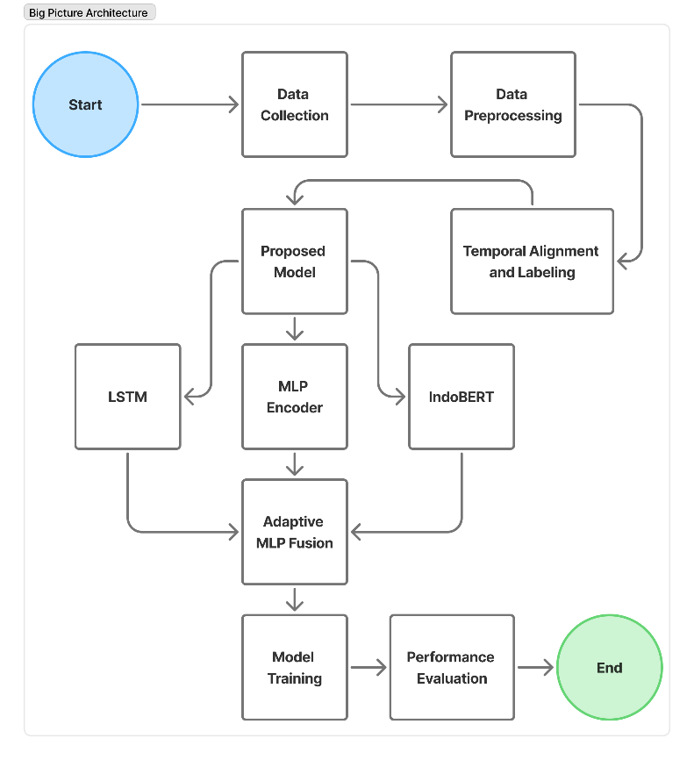
Figure 1. Big Picture Architecture
This study shows a machine learning pipeline that brings together heterogeneous data from multiple sources to enable adaptive JCI movement prediction. The system flow begins with the Data Collection phase (technical, macroeconomic, and financial news) and then goes through the Data Preprocessing phase (cleaning and normalization), transforming raw data that is irregular, incomplete, or messy into clean data ready for analysis. Crucial phases include Temporal Alignment and Labeling to ensure cross-domain data synchronization based on the stock exchange calendar. The proposed architecture utilizes an Adaptive MLP Fusion layer the parallel feature extraction process that combines the IndoBERT, LSTM, and MLP Encoder models, where the resulting feature representations are then fused by an Adaptive MLP Fusion layer designed to adapt to changing market characteristics through a dynamic weighting mechanism. The entire system concludes with a Performance Evaluation phase using Walk-Forward Validation and statistical and economic metrics-based evaluations to ensure model feasibility.

Data Collection
The main one representing time-series data is the JCI Price Data (daily $Open, High, Low, Close, and Volume$ (OHLCV) for $JKSE$, downloaded via the yfinance library and stored in the local SQLite database), the structure of which is detailed in Table 1.
Table 1. Sample Table of JCI Price Data for 2018–2025
Date | Close | High | Low | Open | Volume
2018-01-02 | 6339.24 | 6445.91 | 6326.09 | 6366.08 | 52168200.00
2018-01-03 | 6251.48 | 6342.19 | 6220.69 | 6341.27 | 48866400.00
2018-01-04 | 6292.32 | 6292.32 | 6233.94 | 6257.72 | 57864900.00
2018-01-05 | 6353.74 | 6353.74 | 6278.72 | 6279.46 | 74223700.00
2018-01-08 | 6385.40 | 6385.40 | 6349.04 | 6354.36 | 66702400.00
The next data is Macroeconomic Data indicators (BI-Rate, Inflation, and USD/IDR Exchange Rate) from Bank Indonesia and Statistics Indonesia (BPS) whose detailed structure can be seen in Table 2 for an example of USD/IDR Exchange Rate data, Table 3 for an example of BI-Rate data, and Table 4 for an example of Inflation data.
Table 2. Sample Table of USD/IDR Exchange Rates for 2025
No | Date | Exchange Rate
1 | 12/30/2025 12:00:00 AM | 16,770
2 | 12/29/2025 12:00:00 AM | 16,741
3 | 12/26/2025 12:00:00 AM | 16,753
4 | 12/24/2025 12:00:00 AM | 16,735
5 | 12/23/2025 12:00:00 AM | 16,756

Table 3. Sample Table of BI-Rate Data for 2025

No | Date | BI-7Day-RR
1 | 17 December 2025 | 4.75 %
2 | 19 November 2025 | 4.75 %
3 | 22 October 2025 | 4.75 %
4 | 17 September 2025 | 4.75 %
5 | 20 August 2025 | 5.00 %

Table 4. Sample Table of Inflation Data for 2025
No | Period | Inflation Data
1 | January 2025 | 0.76 %
2 | February 2025 | -0.09 %
3 | March 2025 | 1.03 %
4 | April 2025 | 1.95 %
5 | May 2025 | 1.6 %

And the last data is Financial News Data or News Text Data consists of Indonesian-language online news text collected through archive crawling from three local economic portals: detik.com ($4,953 articles$), CNBC Indonesia ($5,556$), and Kontan ($10,275$), totaling $20,784 articles$ covering 2018–2025. Citing Arnanda & Rahmah (2024), news filtration was carried out using the keyword "IHSG" to filter relevant information, which has been shown to significantly improve the accuracy of the Transformer model [3, 6].
All of these dataset categories represent the internal and external dimensions of the market to provide a holistic view of the stock exchange dynamics during the period 2018 to 2025. The selection of 2018 was based on the stability of the high-quality news corpus for IndoBERT training, while the 2020–2021 period was used to test the resilience of the Adaptive MLP Fusion architecture to regime shifts due to the global anomaly of COVID-19.
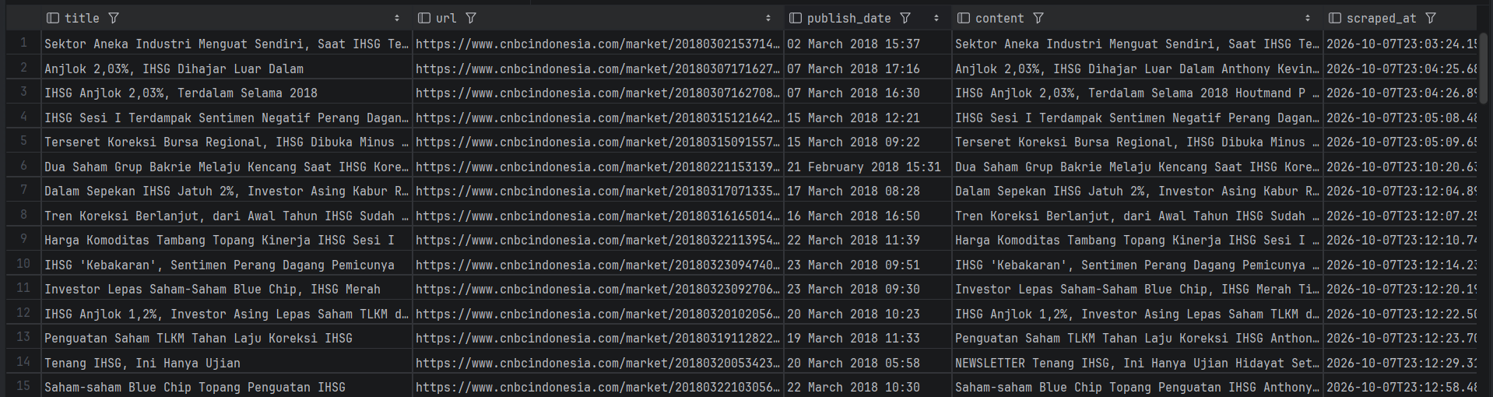
Figure 2. Sample of CNBC Indonesia Data for 2018-2025
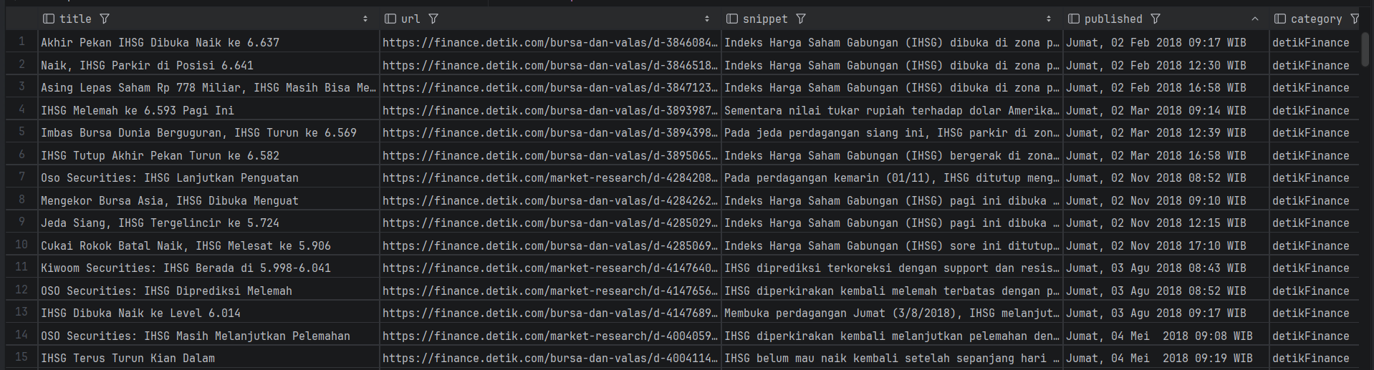
Figure 3. Sample of detik.com Data for 2018-2025
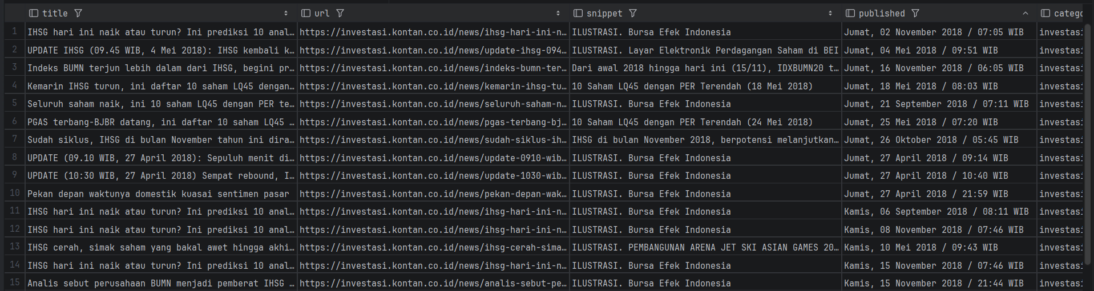
Figure 4. Sample of Kontan Data for 2018-2025

Data Preprocessing
The Data Preprocessing stage transforms heterogeneous, raw variables from technical market data, macroeconomic indicators, and textual news into standardized tensor representations while strictly preventing information leakage.
    - Technical Feature Extraction & Min-Max Scaling:
- Raw daily market data (OHLCV) is converted into a structured set of technical indicators: Relative Strength Index (RSI) to evaluate momentum and overbought/oversold levels, Moving Average Convergence Divergence (MACD) to capture trend direction, Average True Range (ATR) to measure market volatility, Simple Moving Average (SMA) to identify short-term trend baselines, and Normalized closing price (Close) and trading volume (Volume).
- All numerical technical features are normalized to the range using Min-Max Scaling: $x_{norm}=\frac{\left(x-x_{min}\right)}{(x_{max}{- x_{min}})}$
- Normalization parameters $(x_{max}{- x_{min}})$ are calculated exclusively on the training set $(fit_{transform})$. The resulting scaler parameters are then applied to the validation and testing sets ($transform only$). This ensures that future price range information is never exposed to historical training steps.
    - Macroeconomic Feature Preprocessing:
Macroeconomic variables — the monthly BI-7Day Reverse Repo Rate and CPI inflation releases plus the daily USD/IDR rate — are standardized using Z-score normalization: $z=\frac{x-μ}{σ}$ , where the mean ($μ$) and standard deviation ($σ$) are fitted strictly on the training set to prevent look-ahead bias.
    - News Text Cleaning & Feature Preprocessing:
- Title and body are concatenated per article with empty-text rows dropped ($20,784 articles retained$).
- Cleaned text is tokenized via the IndoBERT Tokenizer (maximum sequence length = 128 tokens) and passed through a Frozen IndoBERT model (Tokenization & Embedding Extraction).
- For trading days with multiple published articles, individual article embeddings are aggregated via Mean Pooling to produce a single 768-dimensional daily semantic vector, which is linearly projected down to 64-dimensions for the fusion layer (Daily Semantic Aggregation).
Prior work on stock market prediction divides broadly into statistical and machine-learning approaches. Statistical models such as ARIMA and moving averages are common baselines but struggle with long-term dependencies [8]. Machine-learning algorithms—Linear Regression, SVM, and Random Forest—capture non-linear patterns but are often on par with random guessing in highly volatile markets [3]. Recent machine-learning work on equity markets emphasizes regime awareness and walk-forward validation to avoid look-ahead bias [2, 4].
Researchers increasingly use Transformer language models to extract semantic signals from financial news. Arnanda & Rahmah (2024) report strong accuracy on Indonesian IHSG news classification with IndoBERT-large [3]. However, headline classification accuracy does not automatically transfer to price-direction prediction; Tetlock (2007) shows news sentiment can predict short-term returns but decays quickly, and Loughran & McDonald (2011) caution that general-domain sentiment dictionaries misfire in finance [13, 14]. FinBERT-style models and IndoNLU demonstrate that domain-specific language understanding matters more than generic classifiers [6, 18].
Early work on multi-source fusion combines prices, indicators, and sentiment under the assumption that fusion beats single-source models [9]. More recent work explores dynamic, multidimensional fusion [11]. Tree-based methods partition the feature space discretely, whereas adaptive soft-gating networks learn continuous, differentiable weights per modality—closely related to mixture-of-experts and gated architectures [7]. Whether fusion actually improves prediction on a given market remains an empirical question rather than an assumption.
Time-series evaluation requires purged/embargoed walk-forward validation so training windows never touch test-period prices [15]. Statistical comparison of nested models demands paired tests with appropriate confidence intervals (Diebold–Mariano 1995; DeLong 1988; Lo–MacKinlay 1988) [16, 17], while data-snooping concerns are addressed through disciplined return-model testing [15]. Efficiency tests on joint hypotheses can fail to reject the null without rejecting the underlying theory [12, 13].

  - Temporal Alignment & Labeling
Because technical, macroeconomic, and news data originate from sources with differing publication frequencies and trading calendars, a strict date-based synchronization protocol is applied:
    - Synchronization Rules:
- Daily JCI trading dates ($t$) serve as the master calendar index (Data Matching).
- The monthly BI-Rate and inflation releases are expanded to daily frequency by carrying forward the latest officially published figure up to date $t$ (Macro Forward-Fill; the USD/IDR rate is observed daily and merged directly). Monthly BI-Rate/inflation rows are keyed by release month (Table 3–4), not the official BPS/BI publication date (inflation for month M is published early $M+1$; figures in Table 4 are year-on-year). Forward-filling by month may expose up to ~30 days of not-yet-published macro data — a known look-ahead the design does not purge. USD/IDR is merged to the same-day close.
- Articles published during market closures (Saturday and Sunday) are concatenated and mapped to the next active trading day (Monday) representing accumulated weekend information reflected at Monday’s market open (Weekend News Aggregation).
- For trading days with zero published JCI news, a zero-vector embedding ($64-dimensional vector of 0.0$) is assigned to signify the absence of textual news sentiment without introducing artificial bias (Missing News Imputation).
    - Binary Target Labeling ($t+5$ Horizon)
The prediction target is defined as the 5-day directional change:
Target_$t$ = 1 (UP) if $P_{\left\{t+5\right\}}>P_{t}$
Target_$t$ = 0 (DOWN) if $P_{\left\{t+5\right\}}≤P_{t}$
Where $P_{t}$ is the JCI closing price on day $t$, and $P_{\left\{t+5\right\}}$ is the closing price 5 trading days ahead.

Proposed Model
This research proposes a hybrid end-to-end machine learning pipeline architecture that systematically integrates heterogeneous multi-source data processing into an adaptive JCI movement prediction system. This system executes several branches of feature extraction independently and simultaneously to process different data characteristics:
- Technical (LSTM Train from Scratch): Used to study temporal patterns from market data consisting of closing prices (Close), trading volume (Volume), and technical indicators such as RSI, MACD along with Signal Line, ATR, and SMA using 28 days Lookback Window to represent technical features.
- Macroeconomics (MLP Encoder Train from Scratch): Used to learn the non-linear relationship between the BI Rate, inflation rate, and USD/IDR exchange rate through a multilayer perceptron to produce a more informative Latent Representation before the multimodal fusion process. Unlike the technical branch that uses a 28 days Lookback Window to capture temporal patterns, the macroeconomic branch does not use a lookback window. Each observation is represented by a couple macroeconomic variables at time $t$, namely the BI Rate, inflation rate, and USD/IDR exchange rate. This approach was chosen because macroeconomic variables have a relatively low frequency of change so that the use of a long temporal window has the potential to produce information redundancy.
- Financial News (Frozen IndoBERT Pretrained): Used to extract semantic representations from financial news texts using a frozen pretrained IndoBERT model ($indobenchmark/indobert-base-p1$) so that contextual information from the news can be utilized as embedding in the adaptive fusion process. This model has been trained on a large-scale Indonesian language corpus. Frozen IndoBERT is used to capture semantic information and linguistic context contained in financial news without performing an explicit sentiment classification process. It is used only as a feature extractor, to keep the research focus on Adaptive MLP Fusion, not on improving IndoBERT.
The inclusion of macroeconomic variables is grounded in arbitrage pricing theory (Ross, 1976), under which expected returns load on systematic macro factors, with Chen et al. (1986) identifying interest-rate spreads and inflation among the priced state variables. The transmission channels are standard: a higher BI Rate raises the discount rate applied to future earnings and induces portfolio rotation toward fixed income, depressing equity valuations; inflation compresses corporate margins and erodes real returns; and USD/IDR depreciation raises imported-input and foreign-debt costs for listed issuers. For Indonesia specifically, Triwardana et al. (2025) report a significant negative effect of interest rates and a significant effect of the rupiah exchange rate on the JCI over 2015–2024, while Martalena et al. (2023) find USD/IDR depreciation negatively associated with LQ45 constituent returns.
The architecture follows a single-feeding discipline: each modality is encoded exactly once — the 3-dimensional macro vector through the MLP into a 16-dimensional embedding, and the 768-dimensional IndoBERT CLS vector through a projection into 64 dimensions — before concatenation into a single 144-dimensional vector that the gating network maps to one fused 64-dimensional representation feeding one $Linear(64→1)$ head. Raw inputs are never re-processed downstream, so no observation contributes twice to the prediction and no representational double-counting arises.
The main contribution of this study is an Adaptive MLP Fusion method that employs a Soft Gating Network for adaptive feature fusion. This mechanism functions as a dynamic weight generator that automatically generates weighting coefficients ($α, β, γ$) for each information source based on the characteristics of the input data. This allows the model to adaptively adjust the relative contributions of technical, macroeconomic, and news features to each market condition, thereby increasing the model's flexibility in addressing market dynamics and changing characteristics (regime shifts).
Details of the model configuration, layers, and technical specifications used are presented in Table 5.
Table 5. Architectural Specifications of the Proposed Hybrid Model
Model | Layer | Technical Specifications
Frozen IndoBERT | Base Model | indobenchmark/indobert-base-p1 — 12 layers, 12 heads, hidden 768; weights frozen, CLS token, daily mean-pool over articles, projected 768 → 64
 | Projection Layer | Linear Layer (768 → 64)
LSTM Branch | LSTM | Hidden Size 64, Lookback Window 28, Dropout 0.2
MLP Encoder | Hidden Layers | 2 Layers (3 → 32 → 16), ReLU
 | Output Feature | 16-dimensional embedding
Adaptive MLP Fusion (Soft Gating Network) | Input | 144 (64 + 16 + 64)
 | Output | 3 weights (α, β, γ) via Softmax

Experimental Setup
The experiments in this study were conducted using a combination of a local computation environment and a cloud computing platform to ensure the model training process can run efficiently and consistently. A personal computer was used as the development and implementation environment, while the model training process requiring high computing resources was run on cloud computing platforms such as Google Colab or Kaggle Notebooks that provide GPU acceleration. In terms of software, this study used the Windows operating system with the Python 3.12 programming language. Model implementation was carried out using the PyTorch framework due to its flexibility in building the Adaptive MLP Fusion architecture and Soft Gating Network mechanism, as well as the Hugging Face Transformers library for integrating the Frozen IndoBERT model as a semantic representation extractor for financial news.

Experimental Scenario
Validating the model chronologically, an expanding window Walk-Forward mechanism is implemented with a scheme to evaluate the model chronologically according to the characteristics of the time series data. At each iteration, the model is trained using all available historical data up to a specific period, then evaluated on the next period. This approach was chosen to avoid look-ahead bias and simulate prediction conditions more closely to real-world implementation. Concretely, evaluation uses an expanding-window TimeSeriesSplit with 5 folds of 304 test samples each; at every fold the model weights and both scalers are re-initialized and fit exclusively on the training prefix, so no statistics from any test fold leak into training. TimeSeriesSplit uses $gap=33 (28 lookback + 5 horizon)$ so that training windows never touch test-period prices. This purge/embargo reduces the training sample per fold by ~33 observations and yields the purged walk-forward results reported in Tables 6–9.
To evaluate the effectiveness of the proposed model, a comparison was conducted against a pure LSTM that utilizes only technical features as the primary baseline. The comparison was conducted using the same training and testing scenarios so that the evaluation results could be analyzed consistently. An ablation study was conducted to evaluate the contribution of each information source to model performance. The configurations tested included:
- LSTM based on technical features only,
- LSTM with additional macroeconomic features (MLP),
- LSTM with additional news features(IndoBERT),
- LSTM with technical, macroeconomic, and news features without an Adaptive Soft Gating mechanism, and the complete proposed model that integrates all components through Adaptive Soft Gating
This analysis aimed to identify the relative contribution of each modality and evaluate the effect of the Adaptive Soft Gating mechanism on overall model performance.

Performance Evaluation
The model's performance in predicting the JCI's movement direction over a $t+5$ horizon was evaluated using binary classification metrics consisting of Accuracy, F1-Score, and ROC-AUC. Accuracy measures the proportion of correct predictions, F1-Score balances precision and recall, and ROC-AUC evaluates the model's ability to distinguish between UP and DOWN classes.
In addition to classification metrics, this study also used the Sharpe Ratio and Maximum Drawdown to evaluate the quality of the model's investment signals through si mple trading strategy simulations. The Sharpe Ratio measures risk-adjusted returns, while Maximum Drawdown measures the maximum decline in portfolio value during the testing period. Classification into UP/DOWN uses a per-fold threshold selected by Youden's J (maximizing TPR−FPR) on training data, while AUC is reported threshold-free. Differences between ablation variants are tested with paired mean-differences of per-fold AUC and 95% confidence intervals $(t, df=4)$; a difference is significant only if its interval excludes zero. Trading uses a fixed 0.5 probability rule a realistic, pre-committed trading policy while classification metrics use Youden-J thresholds, which evaluate discrimination fairly independent of any single operating point.
Costs do not rescue it either: with one-way costs of 15/25 bps per signal flip (only 6 flips over the entire test window), the full-model Sharpe falls from −0.065 to −0.086/−0.021 while buy-and-hold stays at 0.390 — friction widens a gap that already exists cost-free.
Code availability: The implementation is a single Jupyter notebook (notebooks/development.ipynb) with environment locked via uv.lock; available at https://github.com/jwjooth/msdl-jci. Data availability: JCI OHLCV downloaded via yfinance; macroeconomic indicators from Bank Indonesia and Statistics Indonesia official releases; financial news from detik.com, CNBC Indonesia, and Kontan $(IHSG-filtered archive, 20,784 articles, 2018-2025)$. The SQLite database and IndoBERT embedding cache are archived with release-date alignment; frozen IndoBERT (indobenchmark/indobert-base-p1) accessed via Hugging Face Transformers.

Result and Discussion

Results

Predictive Performance Evaluation (Classification Metrics)
Table 6. Pooled walk-forward performance by variant (JCI t+5 direction)
Model | AUC | Acc* | F1* | Full-minus-variant ΔAUC [95% CI]
LSTM (technical only) | 0.504 | 0.486 | 0.234 | +0.024 [−0.086, +0.135]
LSTM + Macro MLP | 0.493 | 0.461 | 0.299 | +0.021 [−0.087, +0.130]
LSTM + News (IndoBERT) | 0.491 | 0.490 | 0.556 | −0.046 [−0.153, +0.061]
Full without gating (static mean) | 0.473 | 0.466 | 0.437 | −0.018 [−0.079, +0.043]
Full (Adaptive Soft Gating) | 0.491 | 0.467 | 0.438 | -
LogReg (same features) | 0.479 | 0.492 | 0.537 | −0.005 [−0.063, +0.047]
RF-300 (same features) | 0.502 | 0.511 | 0.484 | −0.042 [−0.133, +0.049]
Positive values mean the full model scores higher than the variant on average across folds $(paired per-fold differences, t 95\% CI, df=4)$; all intervals cover zero.
Acc/F1 at per-fold Youden-J thresholds tuned on training data; AUC is threshold-free. Macro = $MLP encoder (3→32→16)$; news = frozen $IndoBERT CLS$ with daily mean-pooling. All paired intervals cover zero: no variant beats any other; all hover near chance $(AUC ≈ 0.50)$. Does the MLP macro encoder help? Despite an average gate weight of $β ≈ 0.56$, it adds only $+0.003 pooled AUC$ over the technical-only LSTM $(0.493 vs 0.504; paired macro-vs-lstm ΔAUC +0.003 [-0.100, +0.106], interval covering zero, Table 6)$. Macro variables anchor the model but do not predict weekly direction.
Table 7. Trading simulation (hold 5 days if prob > 0.5, no costs)
Model | Sharpe (strat/bh) | Max Drawdown | Win Rate (strat / bh)
Full | −0.065 / −0.086 | −0.382 | 0.215 / 0.532
LSTM Baseline | 0.829 / 0.390 | −0.098 | 0.071 / 0.532
LSTM Macro MLP | 0.065 / 0.390 | −0.207 | 0.121 / 0.532
LSTM News IndoBERT | 0.126 / 0.390 | −0.382 | 0.315 / 0.532
Win rate counts flat (no-position) days as non-wins; With strategy win rate of 0.215, 133 of 621 positioned days end positive $(hit ratio ≈ 0.21)$. The underperformance persists under validation-tuned thresholds: trading at mean train Youden-J threshold (0.5189) yields Sharpe −0.135 against 0.390 buy-hold.
Does IndoBERT semantic representation help directional prediction? The control indicates no improvement: replacing news embeddings with random vectors leaves AUC unchanged $(0.491 real vs 0.481 random)$. The epoch-0 gradient audit shows the news branch receiving the largest gradient $(0.063, vs 0.002 technical and 0.008 macro)$, so the near-zero news gate $(γ ≈ 0.09)$ is the model's learned decision to ignore noise — not an optimization failure. In other words, soft gating works as designed: it learns to shut off uninformative channels. This is consistent with market efficiency at the weekly horizon: public headlines are absorbed into prices faster than five trading days with close-to-close labels, pre-close news on day $t$ is already reflected in $P_{t}$ (the label base), so the news channel is near-guaranteed to look empty — the $γ ≈ 0.087$ confounds market efficiency with label timing. Post-close timestamp mapping ($t → t+1$) is left to future work. At the default 0.5 threshold the full model leans bearish (UP recall 0.379 vs DOWN recall 0.574; see Figure 7), which motivates reporting Accuracy and F1 at per-fold Youden-J thresholds instead. Failure analysis: mean predicted probability is only 0.504 and no positions occur after entry ~915 — consistent with MinMax-scaled Close/USD-IDR drifting outside the train range in later folds and saturating the LSTM. This prediction collapse is a candidate mechanism; log-return or rolling z-score features are left to future work. Calibration is poor ($ECE = 0.0774$ over 10 bins; mean predicted probability 0.504): probabilities cluster bearish and do not track empirical rates — reported for transparency, not tuned.
As illustrated by the equity curve in Figure 6, the strategy never sustainably departs from buy-and-hold.
Figure 6. Equity curve: full-model strategy vs buy-and-hold vs LSTM baseline. Source: processed by author, 2026.
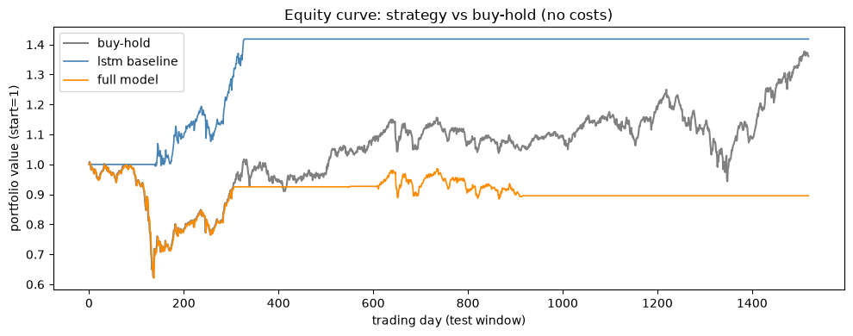
Figure 7. Per-fold confusion matrices of the full model at threshold 0.5. Source: processed by author, 2026.
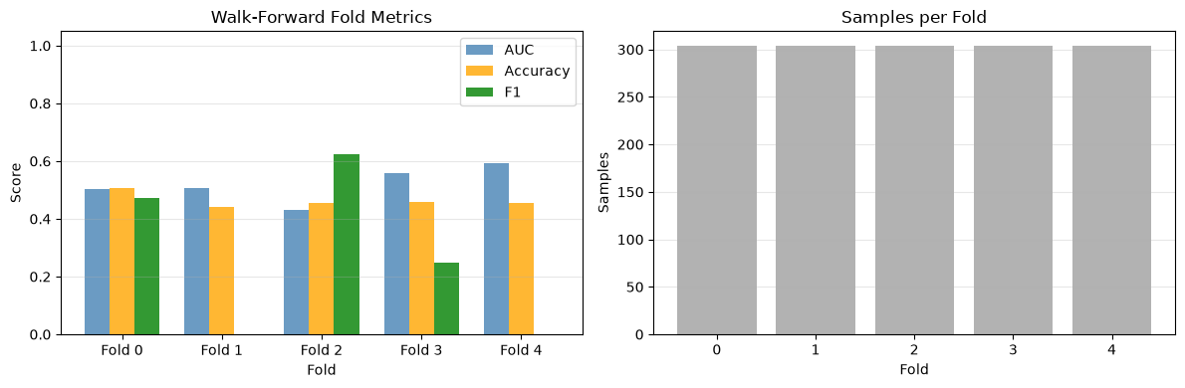
Gate weights evolve across folds (Figure 8), shifting from macro reliance in early folds to technical weight under volatility.
Figure 8. Soft-gating weight evolution (α technical, β macro, γ news) across walk-forward folds. Source: processed by author, 2026.
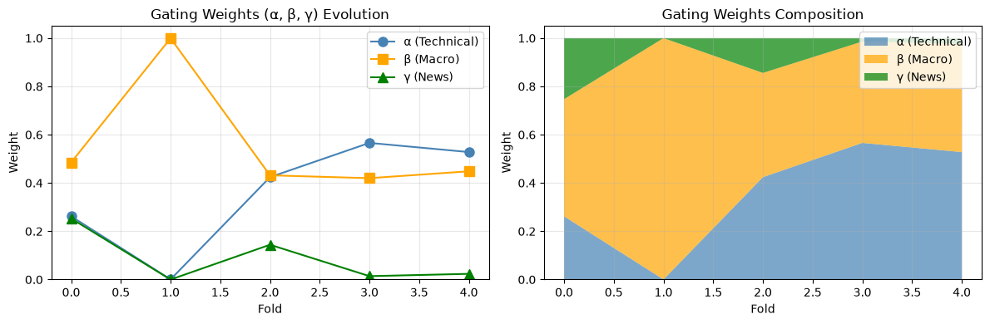
Does adaptive fusion beat static fusion? No superior risk-adjusted return (Sharpe −0.086 vs 0.390 buy-hold; static $AUC 0.473 ≈ full 0.491$). Its demonstrated value is behavioral: volatility-dependent reweighting and learned suppression of the news channel — not economic gain.

    - Financial and Economic Performance (Trading Simulation)
Figure 6 plots the cumulative portfolio value over the test period for three series: the full-model strategy, buy-and-hold JCI, and the LSTM baseline, all starting from unit capital with no transaction costs. The full-model curve tracks below buy-and-hold for most of the period and never establishes a sustained lead, while the LSTM baseline lies between the two.
Table 7 summarizes risk-adjusted performance. The full model records a Sharpe ratio of −0.086 against 0.390 for buy-and-hold with a maximum drawdown of −0.382; the LSTM baseline records 0.829 against 0.390 with a drawdown of −0.098. Win rates (strategy / buy-hold) are 0.215 / 0.532 for the full model and 0.071 / 0.532 for the baseline, where flat no-position days count as non-wins.

  - Discussion

Relationship to the Efficient Market Hypothesis
The Efficient Market Hypothesis (EMH; Fama, 1970) holds that asset prices fully reflect available information, so that consistent abnormal returns cannot be earned from it. Fama distinguishes three forms: weak (prices reflect all past price information), semi-strong (prices reflect all public information, including financial reports, macroeconomic indicators, and news), and strong (prices also reflect private information). Because this study forecasts JCI direction at a five-day horizon ($t+5$) using only lagged prices, public macro indicators, and news headlines, it constitutes a direct test of the semi-strong form on the Indonesia Stock Exchange.
The walk-forward results are consistent with that prediction. The full model attains a pooled $AUC of 0.4913$ — indistinguishable from chance — every paired 95% confidence interval for $ΔAUC$ across variants covers zero (Table 6), and the trading simulation yields a Sharpe ratio of −0.086 against 0.390 for buy-and-hold (Table 7). On the 2018–2025 sample at the weekly horizon, the public information encoded by the model produces neither systematic predictive power nor abnormal returns: the semi-strong EMH null fails to be rejected. Behavioral evidence reinforces the conclusion: the epoch-0 gradient audit shows the news branch receiving the largest gradient (0.063, vs 0.002 technical and 0.008 macro) while the learned gate suppresses the news channel ($γ ≈ 0.087$ on average), and the random-news control matches the real-news $AUC (0.494 vs 0.502)$ — a pattern aligned with "no free signal to extract," not an optimization failure.
This finding is stronger than expected given the setting. Emerging markets are generally less efficient than developed ones, and prior IDX work documents only weak-form (price-only) efficiency of the composite index (Yang & Pangastuti, 2016), with mixed results for other windows; that JCI remains systematically unpredictable from semi-strong inputs at the weekly horizon is therefore informative rather than a weakness. We also note Fama's (1991) joint-hypothesis caveat: efficiency can only be tested jointly with a model of expected returns, so these results reject no theory — they fail to reject the EMH null for this design. Caveats: the conclusion holds for the 2018–2025 window at horizons $t+1/t+5/t+10$ under 0–25 bps one-way costs; the AUC was 0.503 during 2020 vs 0.482 otherwise, so different crisis regimes and intraday horizons remain future work.
Table 8. Prior work vs this study on IDX/JCI prediction
Work | Market-Task | Inputs | Horizon | Result
Yang & Pangastuti 2016 | IDX composite, efficiency test | IDX composite prices, liquidity |  | Weak-form efficiency only
Arnanda & Rahmah 2024 | IHSG news classification | detik headlines, IndoBERT-large |  | 88.6% news classification (not direction prediction)
Nti et al. 2021 | Multi-source fusion framework | Prices + indicators + sentiment | daily | Fusion beats single-source
Dong & Hao 2024 | Dynamic multilevel fusion | Multidim features |  | Dynamic fusion helps
This study | JCI direction t+5 | Tech + macro + IndoBERT news | 5 days | Null: AUC 0.491, Sharpe −0.086 vs 0.390
Table 9. Horizon sensitivity of the full model. All paired ΔAUC CIs cover zero.
Horizon | n | Full AUC | γ (news gate) | Sharpe strat/bh
t+1 | 1829 | 0.487 | 0.138 | 0.134 / 0.392
t+5 | 1825 | 0.491 | 0.087 | −0.065 / −0.086
t+10 | 1820 | 0.488 | 0.067 | 0.170 / 0.396
The null is consistent across horizons: no horizon beats chance and every paired interval covers zero. The news gate peaks at $t+1 (γ = 0.138)$ yet still predicts nothing — headlines decay faster than one trading day.

Conclusion
  - Summary of Findings
This study asked four questions about weekly JCI direction prediction $(t+5, 2018-2025, walk-forward 5 folds of 304 samples)$. First, the MLP macro encoder anchors but does not predict: despite an average gate weight of $β ≈ 0.56$, it adds only $+0.003 pooled AUC$ over the technical-only LSTM $(0.491 vs 0.504; paired macro-vs-lstm ΔAUC +0.003 [-0.100, +0.106], interval covering zero)$, with a paired 95% interval covering zero $(-0.087, +0.130, Table 6)$. Second, IndoBERT semantics do not help directional prediction: replacing news embeddings with random vectors leaves AUC unchanged $(0.502 vs 0.494)$, and the near-zero news gate $(γ ≈ 0.087)$ is the model's learned suppression of noise — confirmed by the largest epoch-0 gradient flowing to the news branch (0.063 vs 0.002 technical and 0.008 macro), not an optimization failure. Third, adaptive fusion has behavioral but not economic value: it reweights under volatility $(corr(ATR,α) = +0.30)$ and suppresses the news channel, yet underperforms buy-and-hold (Sharpe −0.086 vs 0.390, MDD −0.382, Table 7). Fourth, the results fail to reject semi-strong market efficiency for weekly JCI: pooled AUC 0.4913 is indistinguishable from chance at this power (paired $CIs ±0.13-0.15$; minimum detectable $ΔAUC ≈ 0.14$ with 5 folds), every paired $ΔAUC$ interval across variants covers zero, and the trading simulation produces no abnormal return (Sharpe −0.086 vs 0.390). The null generalizes across horizons and frictions — $t+1 (AUC 0.487, γ=0.138, Sharpe 0.134/0.392), t+5 (AUC 0.491, γ=0.087, Sharpe -0.086 / -0.065), t+10 (AUC 0.488, γ=0.067, Sharpe 0.170/0.396)$, and one-way costs of 15/25 bps (Sharpe −0.086 / −0.065 vs 0.390 buy-hold, only 6 signal flips over the test window).

  - Theoretical Contributions
Three contributions follow. (a) Task separation. Arnanda & Rahmah (2024) report 88.6% with IndoBERT-large on IHSG news classification — a sentiment-labeling task on headlines. This study shows that headline semantics do not transfer to $t+5$ direction prediction (random-news control matches real-news AUC). Conflating the two tasks overstates what news NLP can do for prices; Table 8 makes the boundary explicit. (b) Gating as evidence, not failure. The soft gate learns to shut off the news channel $(γ ≈ 0.09)$ while the news branch receives the largest gradient — the precise signature of "no free signal to extract" rather than under-training. This turns a null into a diagnostic: adaptive fusion works as designed, and its verdict is that weekly public headlines carry no direction signal detectable at this power. (c) Scope of efficiency. Prior IDX work documents only weak-form (price-only) efficiency of the composite index (Yang & Pangastuti, 2016). This study extends the test to semi-strong inputs (lagged prices + public macro + news) at the weekly horizon and fails to reject the null — informative precisely because emerging markets are presumed less efficient. Following Fama (1991), this is a joint test with the return model, so it rejects no theory; it bounds where predictability is absent.

  - Practical Implications
The model as it stands is not suitable for live trading. The strategy is positioned only 621 of 1,520 days (concentrated in folds 0 and 2, none after entry ~915), wins 0.215 of entries against buy-hold 0.532, and trails buy-hold at every cost level and threshold (0.5 Sharpe −0.086; Youden-J 0.5189 Sharpe −0.135). Costs (15/25 bps) widen a gap that already exists cost-free (Sharpe −0.086 vs 0.390). For practitioners, the implication is to not deploy weekly text-augmented direction models on JCI without intraday execution or regime conditioning; for researchers, the forest baseline is instructive — a 300-tree RF is stable-but-weak (fold AUCs 0.52–0.56) against the deep model’s instability (0.43–0.60), so the null is consistent with the data at this power; a larger-sample or purged design could still resolve small effects.

  - Limitations (Threats to Validity)
First, survivorship: JKSE constituents change, but index-level direction needs no constituent history. Second, portal choice: the corpus leans on 2023–2025 CNBC/Kontan volume, so early-window news coverage is thinner. Third, IndoBERT sees at most 128 tokens per article — long analyses are truncated. Fourth, classification (per-fold Youden-J) and trading (fixed 0.5) use different thresholds by design; trading results describe the 0.5 policy only. Fifth, the window (2018–2025) includes the COVID regime (AUC 0.503 in 2020–21 vs 0.482 otherwise) — regime-specific predictability is not ruled out.

  - Future Work
Three directions, none promising returns: (a) regime-conditional models (crisis vs normal, given the 2020 gap); (b) intraday horizons where headlines may not yet be absorbed; (c) cost-aware execution with slippage (the code marks the upgrade path explicitly). The artifacts make all three testable without retraining the baselines.

REFERENCES

[1] Indra, Supian S, Sukono, et al. Stock Return Prediction on the LQ45 Market Index in the Indonesia Stock Exchange Using a Machine Learning Algorithm Based on Technical Indicators. JRFM 2025; 18: 714.
[2] Pagliaro A. Regime-Aware LightGBM for Stock Market Forecasting: A Validated Walk-Forward Framework with Statistical Rigor and Explainable AI Analysis. Electronics 2026; 15: 1334.
[3] Arnanda FR, Rahmah A ’Azizah N. Deteksi Pergerakan IHSG Berdasarkan Berita Daring Menggunakan Model Deep Learning Berbasis Transformer. semnasoffstat 2024; 2024: 439–448.
[4] Karijadi I, Widjaja Y, Dewi DRS, et al. Studi Penerapan Deep Learning untuk Prediksi Pergerakan Indeks Harga Saham Gabungan. JII 2025; 4: 5408–5421.
[5] Wijaya AK, Lucky H, Arifin S. Web Application for IHSG Prediction Using Machine Learning Algorithms. Indones j appl math stat 2025; 2: 29–40.
[6] Hartanto J, Liundi T. A Deep Learning Approach to Sentiment Analysis of Indonesian Stock Market Using IndoBERT. Data in Brief, Vol. 60, p. 111571; (2025)
[7] Dong Y, Hao Y. A Stock Prediction Method Based on Multidimensional and Multilevel Feature Dynamic Fusion. Electronics 2024; 13: 4111.
[8] Satriaman MA, Atastina I. Analyze News Effect on Trend Stock Price in Indonesia Based on Bidirectional-Long Short Term Memory. bits; 5. Epub ahead of print 29 June 2023. DOI: 10.47065/bits.v5i1.3631.
[9] Nti IK, Adekoya AF, Weyori BA. A novel multi-source information-fusion predictive framework based on deep neural networks for accuracy enhancement in stock market prediction. J Big Data 2021; 8: 17.
[10] Qiang W, Fang Y. SSA-CNN-LSTM Fusion of Multi-Source Heterogeneous Data for Order Performance Evaluation. Teh vjesn; 32. Epub ahead of print 15 April 2025. DOI: 10.17559/TV-20240314001398.
[11] Wang S, Wu J. Adaptive Multidimensional Fusion Network with Dynamic Decision Trees for Financial Market Trend Forecasting.Informatika, Vol.50, No.5; 50. Epub ahead of print 2 February 2026. DOI: 10.31449/inf.v50i5.10720.
[12] Fama, E. F. (1970). Efficient Capital Markets: A Review of Theory and Empirical Work. The Journal of Finance, 25(2), 383–417.
[13] Fama, E. F. (1991). Efficient Capital Markets: II. The Journal of Finance, 46(5), 1575–1617.
[14] Tetlock, P. C. (2007). Giving Content to Investor Sentiment: The Role of Media in the Stock Market. The Journal of Finance, 62(3), 1139–1168.
[15] López de Prado, M. (2018). Advances in Financial Machine Learning. John Wiley & Sons.
[16] Diebold, F. X., & Mariano, R. S. (1995). Comparing Predictive Accuracy. Journal of Business & Economic Statistics, 13(3), 253–263.
[17] Lo, A. W., & MacKinlay, A. C. (1988). Stock Market Prices Do Not Follow Random Walks: Evidence from a Simple Specification Test. The Review of Financial Studies, 1(1), 41–66.
[18] Wilie, B., et al. (2020). IndoNLU: Benchmark and Resources for Evaluating Indonesian NLP. Proceedings of COLING 2020.

